目录

VR PHYSICAL BODY(V2.0.3) 1

1.How to set up 1

2.Use your own model to make a vr physical body 3

3.Adjust your hand posture 4

4.Edit custom hand pose 5

# VR PHYSICAL BODY(V2.0.3)

## 1.How to set up

The **URP** example template is recommended. If you are using the **built-in** rendering engine, click [***here***](https://github.com/vrnightcrawler/vrnightcrawler.github.io/tree/master/ReadMe%20of%20my%20assets) to download the conversion package.

1. Install the **OpenXR** and **XR Interaction Toolkit**

2. Import the resource package

3, You may be prompted to add TextMeshPro, just follow it

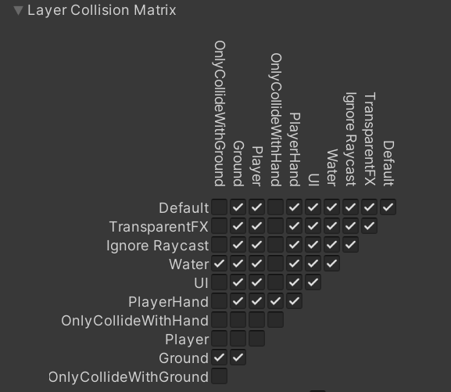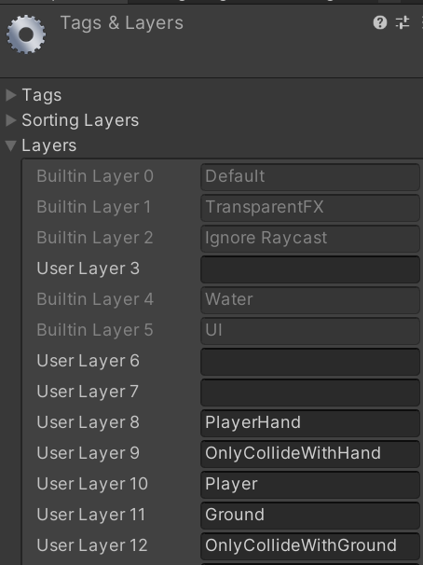4. **Add Layer** and set **collision matrix**, as shown in the figure

5. Run it and add the missing tag according to the error

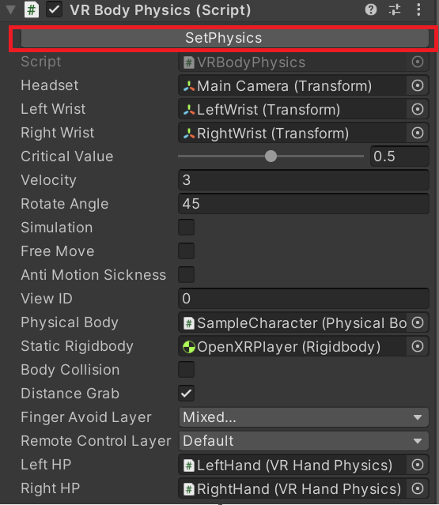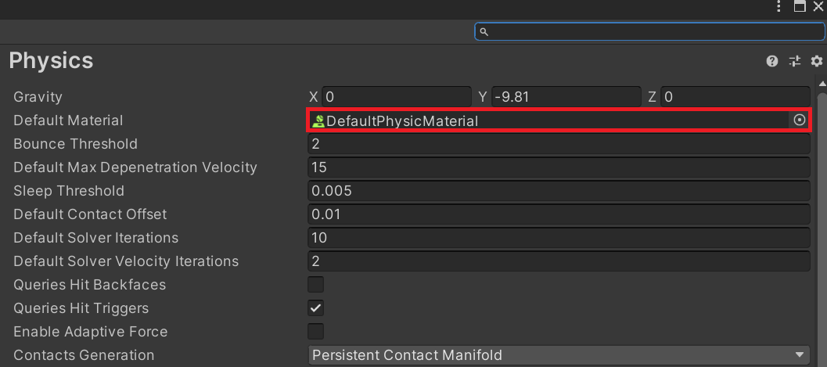6. Click ‘**SetPhysics**’of the VRBodyPhysics script. Then set ‘**DefaultPhysicsMateria**l’ as the default physical material. Please manually set the fixed time to 0.01s. Because it seems like changing the fixed time in the script, the next time you open it will be restored by Unity to the default value of 0.02.

7. Add **‘Ground’** layer to all the floors.

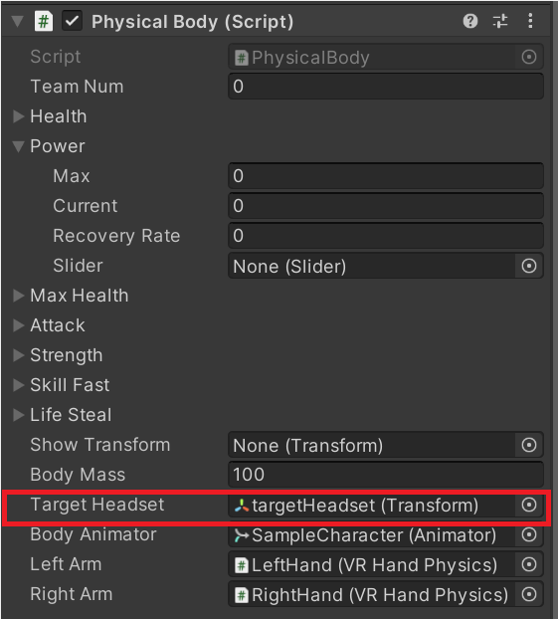8. After generating VR physical body, if your camera is blocked by the model head at runtime, you can **increase the near clipping planes** of the camera, and **adjust the local position of TargetHeadset**

## 2.Use your own model to make a vr physical body

1. 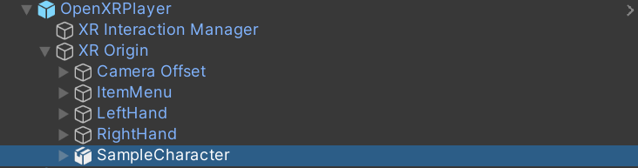Remove **‘Sample Character’** under **‘OpenXRPlayer’**, and drag your own model into your scene.
2. Add a **‘Physical Body’** script to your model. Colliders are automatically created when the **‘Physical Body’** script is added.
3. Check the body and hand colliders for fine adjustments.

## 3.Adjust your hand posture

1. Unpack prefab of your character.
2. 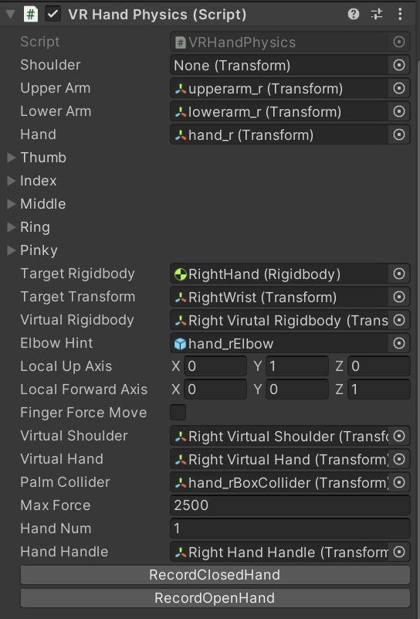Navigate to the **‘VR Hand Physics’** script
3. Right-click on **‘VRHandPhysics’** and execute the corresponding function to show the recorded poses. If you are not satisfied with the default **open/closed** posture, you can adjust fingers to **open/closed** posture in editor and click the corresponding button to record.
4. As for the auxiliary grasping script **‘Handle’**, its coordinate axes are partially aligned with the gameobject **‘HandHandle**, according to the selected alignment mode. Finger poses are automatically calculated without editing.
5. When **Y or YZ** mode is selected, **loose grabbing** is supported. Press index trigger to move your hand along the axis (Y mode also supports rotation). Note that the ends of the ‘Handle’ trigger should be some distance from the ends of the model to limit the range of movement of your hand.

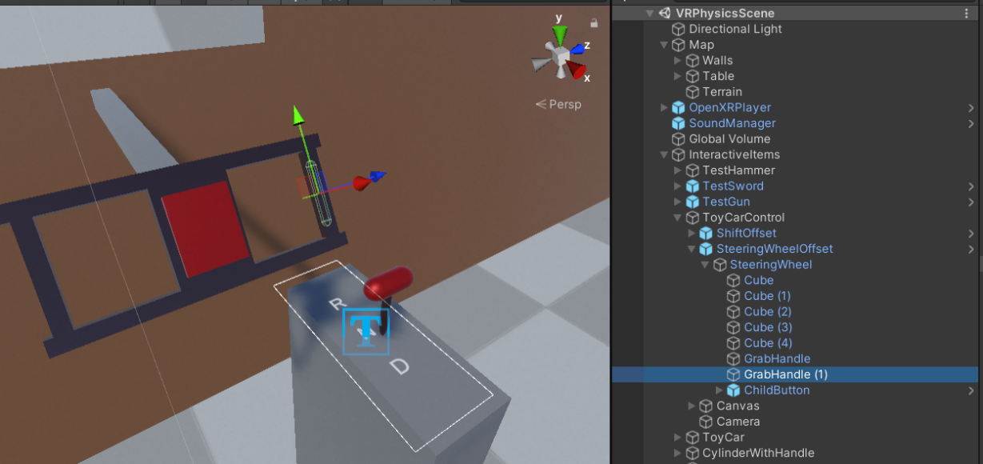

## 4.Edit custom hand pose

1. Click **‘Align Transform**’. Your hands will move to the handle.

2. Move your hands and fingers to achieve an ideal holding position. Just move your **wrist, thumb and index** finger. The rotation of other fingers is calculated automatically at runtime.

3. If you only need a static holding position, record **open and closed** pose for the same pose.

4. Remember to **revert transform** when you are finished recording

You can watch the instructional video on the asset store page to get a step-by-step guide. Pay attention to the version, some may be outdated. If there is a difference, refer to the latest version of the instructions.

Welcome to [my discord](https://discord.gg/3FYnhMCxQW).

If you have any questions, please contact my email: [vrnightcrawler@gmail.com](mailto:vrnightcrawler@gmail.com)